100 AI Interview Questions and Answers



**Anish Mahapatra**

Contents

List of Figures 4

Introduction 5

Q. What is the Gartner Hype Cycle? 5

Structure of the blog 6

**Part A: Topic-Based Questions** 6

1 AutoML 7

Q. What is Auto ML and how does it work? 7

Q. What are some ways to implement AutoML? 7

Q. What is transfer learning and how does it compare to a neural architecture approach? 7

Q. What is GitHub’s copilot? Is it an implementation of AutoML – explain! 7

Q. How does AutoML work? 8

2 MLOps 8

Q. What is MLOps and how does it work? 8

Q. Explain how the MLOps lifecycle can be applied 9

Q. What is the difference between MLOps and DevOps? 9

Q. What are the components of MLOps? 9

3 AI Cloud Service 10

Q. What is an API? How do we deploy our own API to productionalize a ML Model? 10

Q. What are the popular Cloud Services that support AI implementations? Explain! 10

Q. What Cloud Service would you prefer? Why? 10

Q. What are some scenarios where AI Cloud Service could be used to increase ROI? 10

Q. What are the benefits of Machine Learning on the cloud? 10

4 NLP: Natural Language Processing 10

Q. What is NLP? Explain some use-cases of NLP? 10

Q. What are chatbots? What are the various implementations of chatbots used? 10

Q. What are the main issues faced by companies when implementing chatbots? 10

Q. Explain some NLP use-cases. 10

Q. How does Transfer Learning aid in building better and faster NLP models? What are the top three most popular implementations of pretrained language models? 11

5 AI Governance & Scalable AI 11

Q. Now that large companies are leveraging AI to make decisions that affect human beings everyday, it is important to critique the algorithms implemented. On that note, what is AI governance? 11

Q. What are the components of AI Governance? 11

Q. Good AI exists. Looking at the top companies in the world, we know that a robust framework exists where AI can scale. How do the best compnies in the world build Scalable AI? 11

Q. What are the difficultes when it comes to scaling implementations of AI? 11

Q. State out the Enterprise AI Journey. 12

6 XAI / Explainable AI 13

7 Ethical AI 13

8 Cyber Security AI 13

9 RPA: Robotic Process Automation 13

10 GANs” Generative Adversarial Networks 13

**Part-B: Scenario-Based Questions** 13

Q. How can NLP be leveraged to tackle Fake News and Cyber Bullying? 13

Q. How would you build a governance model for AI in Healthcare. Give examples. 13

Q. Gartner’s report says that 87% of ML Models do not make it to production. What are some of the gaps in the real world when it comes to productionalizing ML Models? 13

1 Real World AI 13

2 Mainstream Computer Vision 13

3 Federated Learning 13

4 Enterprise-Grade AI Solutions 13

5 Future of AI 14

# List of Figures

Figure 1: Data Science is a subset of Artificial intelligence 5

# Introduction

With so many pseudo-data scientists cropping up due to numerous courses that offer theoretical learning, the questions in interviews is getting streamlined to filter those that understand how real-world implementation works. It is important to understand how data flows in the real world and what sort of questions are being discussed across companies.

**The value of a company lies solely in the interview process.**

Interviews across companies are growing to appreciate those that have an end-to-end understanding of how problems can be dealt with over theoretical understanding. This detailed blog is dedicated to help you understand the latest trends in the industry and how you can absorb them. Everything you will need to know for an interview will be detailed out here. We will start off with by understanding what the trends in artificial intelligence are.

## Q. What is the Gartner Hype Cycle?

Gartner is a market leader in market research. The Gartner Hype Cycle Methodology is an industry-approved representation of how a technology or application will mature over time. It represents initial interest, a peak in its hype, rolls down to reduced interest in the technology followed by maturity and implementation. A lot of demand in the market comes through in two points in this cycle, in the peak and the maturity. That’s where most of the money can be made from a corporate job.

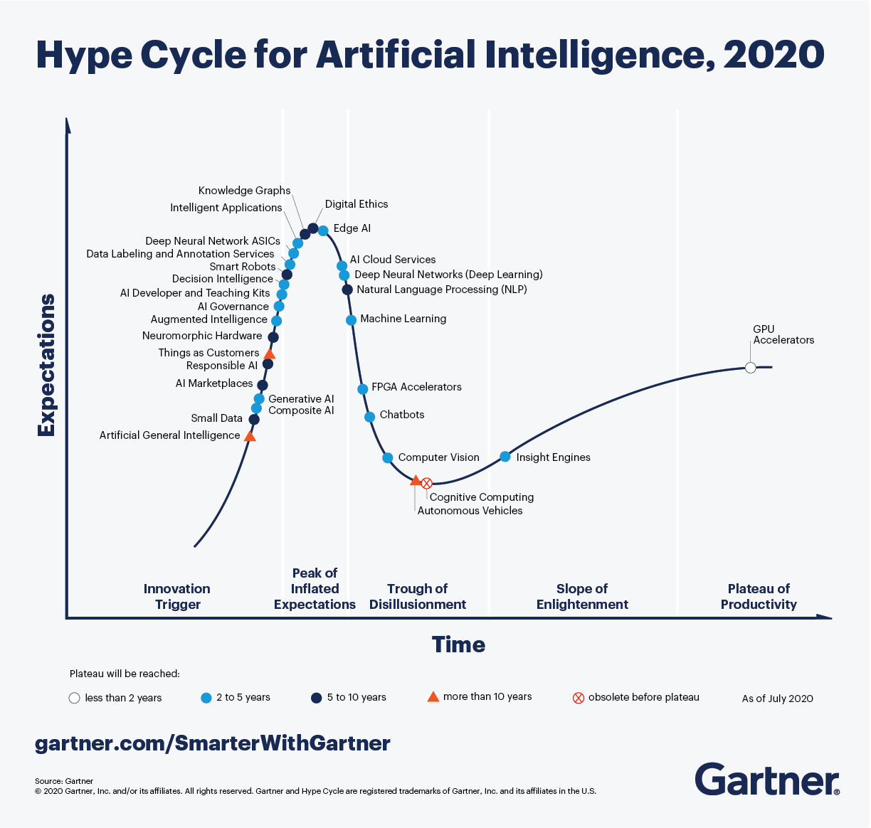

Looking at the Hype Cycle for artificial intelligence, focusing on the **blue** dots in the cycle, those are topics that are of interest in the next two to five years. An understanding of various innovation triggers in the space of artificial intelligence will help elevate conversation and make you stand out in the eyes of the interviewer. The answer is never to simply answer the question, but add an additional layer of context that will stick.

This blog will not tell you exactly how to answer questions when asked. It will explain what an instace of the best-in-class answes would sound like. We will try to use as many visual aids and examples to answer so that you can apply it in multiple scenarios and interviews.

# Structure of the blog

A lot of thought was put in as to what would make most sense in terms of structure when putting forth 100 AI interview questions and answers. For the first 50 questions, we will go over 5 questions each for 10 topics followed by 50 scenario-based questions. In the first section, we will try and cover as many current and future proof topics that we have seen being asked in some of the best analytics companies.

# **Part A: Topic-Based Questions**

Before we deep-dive into the questions below, let’s understand more about artificial intelligence and where it falls in the spectrum. In the recent past, Data Science has taken off in the space of technology, even being crowned as the Sexiest Job of the 21st Century. Let’s understand where Data Science belongs in the space of Artificial Intelligence.

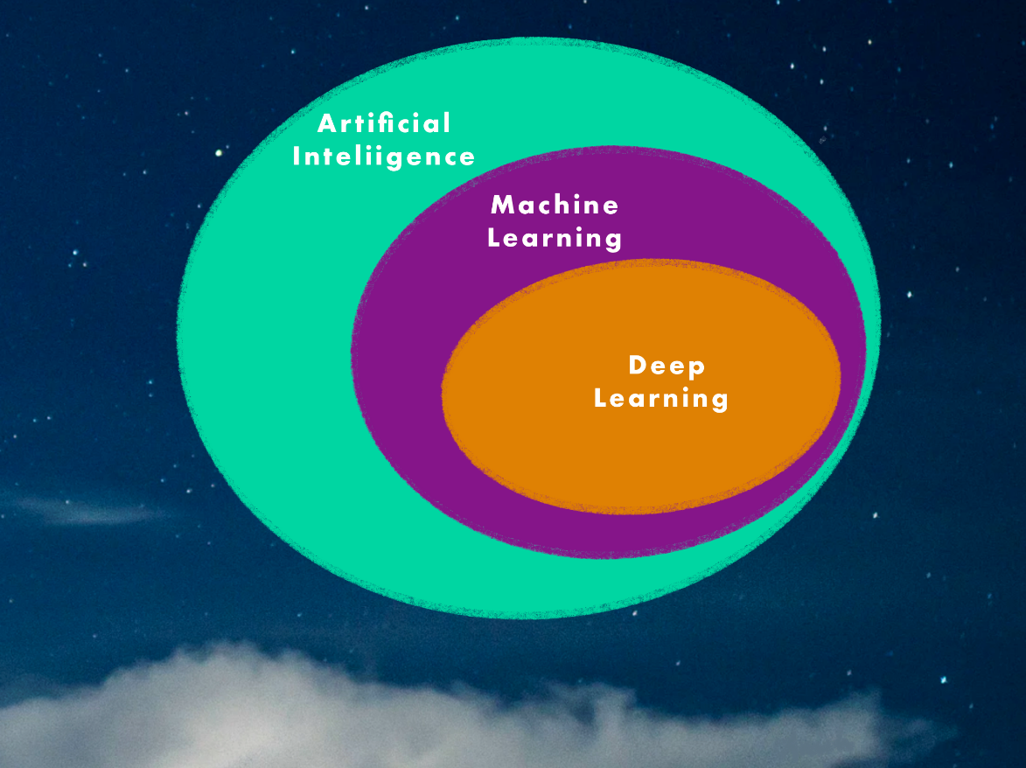

Figure 1: Data Science is a subset of Artificial intelligence

* Deep Learning: Subset of machine learning that leverages neural networks to train itself to perform layered tasks such as speech and image recognition
* Machine Learning: Subest of Artificial Intelligence which enables algorithms to learn without being explicitly programmed
* Artificial Intelligence: Programs with the ability to learn and reason like human beings

When explaining questions to an interviewer, remember, they are smarter than they look. No one knows everything about any topic. Especially in a subject like Artificial Intelligence, where new things are coming up at an exponential rate. When answering questions, be humbe and truthful. If you know the answer to the question, answer confidently. If you are unsure, be vocal about your thought process and the way you are thinking – take inspiration from the examples below and explain the answer to the interviewer through your experiences from projects and learnings. Alright, we have had enough fun building up to this moment, let’s dive right into the questions!

# 1 AutoML

## Q. What is Auto ML and how does it work?

A.

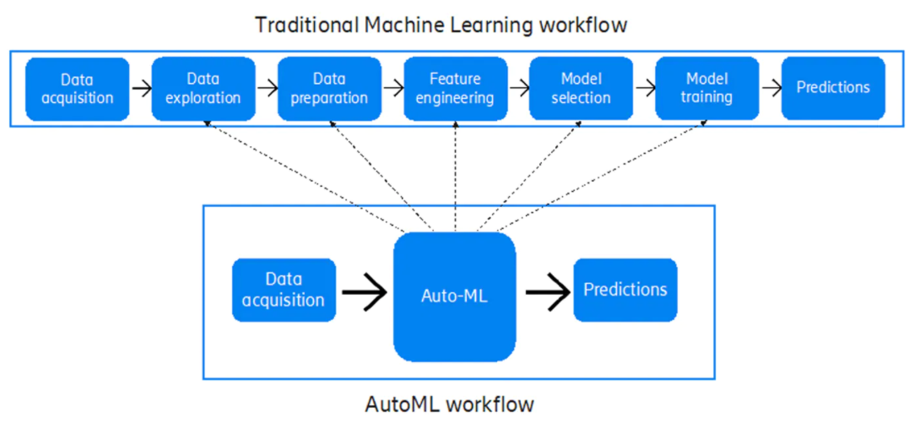

## Q. What are some ways to implement AutoML?

A [10 Popular AutoML Tools Machine Learning Developers Can Use (analyticsindiamag.com)](https://analyticsindiamag.com/10-popular-automl-tools-developers-can-use/)  
[AutoML: 7 Tools to Get You Started with Data Science Automation - victorzhou.com](https://victorzhou.com/posts/tools-for-auto-ml/)  
[11 Most Amazing AutoML Tools To Automate The Machine Learning (techgrabyte.com)](https://techgrabyte.com/11-automl-tools-automate-machine-learning/)

## Q. What is transfer learning and how does it compare to a neural architecture approach?

A. [Google's AutoML: Cutting Through the Hype · fast.ai](https://www.fast.ai/2018/07/23/auto-ml-3/)

## Q. What is GitHub’s copilot? Is it an implementation of AutoML – explain!

A. [GitHub And OpenAI Jointly Launch A New AI Tool, Copilot, Your AI pair programmer | MarkTechPost](https://www.marktechpost.com/2021/06/30/github-and-openai-jointly-launch-a-new-ai-tool-copilot-your-ai-pair-programmer/)  
[Is GitHub Copilot a blessing, or a curse? · fast.ai](https://www.fast.ai/2021/07/19/copilot/)

## Q. How does AutoML work?

A. [How does AutoML works?. “AutoML is not complete Data science… | by jeetendra gangele | Medium](https://medium.com/@gangele397/how-does-automl-works-b0f9e45fbb24)  
[How does Automated machine learning (AutoML) work? (eduonix.com)](https://blog.eduonix.com/artificial-intelligence/brief-introduction-automl/)  
[How does AutoML work? | MLJAR Automated Machine Learning](https://mljar.com/blog/how-does-automl-work/)  
[AutoML Tables Beginner’s guide  |  Google Cloud](https://cloud.google.com/automl-tables/docs/beginners-guide)

# 2 MLOps

## Q. What is MLOps and how does it work?

A.

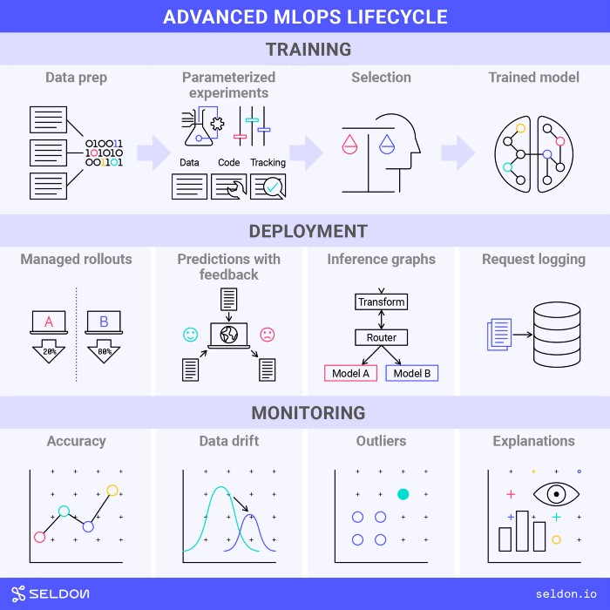

Figure 2: The end to end MLOps Lifecycle  
(Image by seldon.ai under the [CC BY-SA 4.0](https://creativecommons.org/licenses/by-sa/4.0/))

Q. What are some of the ways to push a ai/ml model to production? Explain the tech stack.

## Q. Explain how the MLOps lifecycle can be applied

A. [Applying the MLOps Lifecycle. Understand MLOps needs and how they… | by Ryan Dawson | Towards Data Science](https://towardsdatascience.com/applying-the-mlops-lifecycle-3b60033b7cbf)  
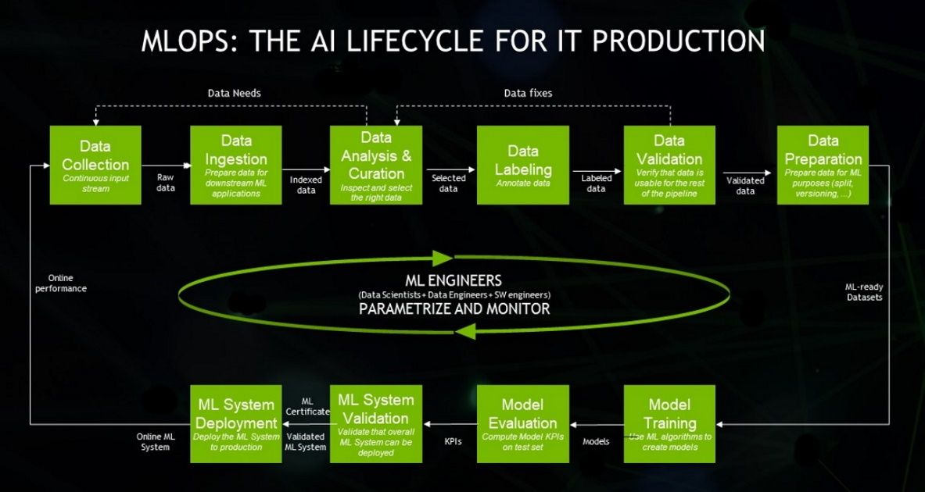

## Q. What is the difference between MLOps and DevOps?

A. [Applying the MLOps Lifecycle. Understand MLOps needs and how they… | by Ryan Dawson | Towards Data Science](https://towardsdatascience.com/applying-the-mlops-lifecycle-3b60033b7cbf)  
[MLOps vs DevOps. This article goes through the… | by Marco Susilo | Towards Data Science](https://towardsdatascience.com/mlops-vs-devops-5c9a4d5a60ba)  
[MLOps vs DevOps. What’s the difference? | by Demetrios Brinkmann | MLOps.community | Jun, 2021 | Medium](https://medium.com/mlops-community/mlops-vs-devops-whats-the-difference-60678e628756)  
[What Is The Difference Between DevOps And MLOps? (valohai.com)](https://valohai.com/blog/difference-between-devops-and-mlops/)

## Q. What are the components of MLOps?

A.

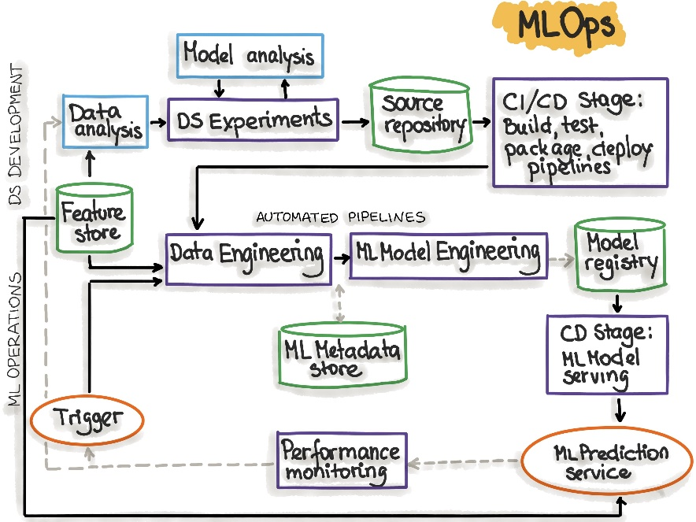

# 3 AI Cloud Service

## Q. What is an API? How do we deploy our own API to productionalize a ML Model?

A. [Deploying Machine Learning Model In Production (analyticsvidhya.com)](https://www.analyticsvidhya.com/blog/2017/09/machine-learning-models-as-apis-using-flask/)

## Q. What are the popular Cloud Services that support AI implementations? Explain!

A. FLASK and REST API   
[Comparing ML as a Service (MLaaS): Amazon AWS, IBM Watson, MS Azure | AltexSoft](https://www.altexsoft.com/blog/datascience/comparing-machine-learning-as-a-service-amazon-microsoft-azure-google-cloud-ai-ibm-watson/)   
[Data Science in the Cloud. Azure vs AWS vs GCP | by Ilai Bavati | Towards Data Science](https://towardsdatascience.com/data-science-in-the-cloud-239b795a5792)   
[Why ML Capabilities Of GCP Is Way Ahead Of AWS & Azure (analyticsindiamag.com)](https://analyticsindiamag.com/why-ml-capabilities-of-gcp-is-way-ahead-of-aws-azure/)   
[AWS vs Azure vs Google Cloud: What's the best cloud platform for enterprise? | Computerworld](https://www.computerworld.com/article/3429365/aws-vs-azure-vs-google-whats-the-best-cloud-platform-for-enterprise.html)   
[Comparing Google Cloud Platform, AWS and Azure | by Georgian | Georgian Impact Blog | Medium](https://medium.com/georgian-impact-blog/comparing-google-cloud-platform-aws-and-azure-d4a52a3adbd2)

## Q. What Cloud Service would you prefer? Why?

A. GCP

## Q. What are some scenarios where AI Cloud Service could be used to increase ROI?

A. [Explore AWS AI and machine learning services (amazon.com)](https://aws.amazon.com/machine-learning/)

## Q. What are the benefits of Machine Learning on the cloud?

A. [The Benefits of Doing Machine Learning and Analytics in the Cloud | The TIBCO Blog](https://www.tibco.com/blog/2019/12/09/the-benefits-of-doing-machine-learning-and-analytics-in-the-cloud/)   
[4 Key Benefits of Machine Learning in Cloud: Everything You Need to Know | upGrad blog](https://www.upgrad.com/blog/key-benefits-of-machine-learning/)   
[What are the Benefits of Machine Learning in the Cloud? - Cloud Academy](https://cloudacademy.com/blog/what-are-the-benefits-of-machine-learning-in-the-cloud/)

# 4 NLP: Natural Language Processing

## Q. What is NLP? Explain some use-cases of NLP?

A. [What is Natural Language Processing? | IBM](https://www.ibm.com/cloud/learn/natural-language-processing)   
[AI - Natural Language Processing - Tutorialspoint](https://www.tutorialspoint.com/artificial_intelligence/artificial_intelligence_natural_language_processing.htm)

## Q. What are chatbots? What are the various implementations of chatbots used?

A.

## Q. What are the main issues faced by companies when implementing chatbots?

A.

## Q. Explain some NLP use-cases.

A. [Cloud Natural Language  |  Google Cloud](https://cloud.google.com/natural-language)

## Q. How does Transfer Learning aid in building better and faster NLP models? What are the top three most popular implementations of pretrained language models?

A. [10 Leading Language Models For NLP In 2021 (topbots.com)](https://www.topbots.com/leading-nlp-language-models-2020/)

# 5 AI Governance & Scalable AI

## Q. Now that large companies are leveraging AI to make decisions that affect human beings everyday, it is important to critique the algorithms implemented. On that note, what is AI governance?

A. [The shape of AI governance to come - KPMG Global (home.kpmg)](https://home.kpmg/xx/en/home/insights/2020/12/the-shape-of-ai-governance-to-come.html)   
[perspectives-on-issues-in-ai-governance.pdf](https://ai.google/static/documents/perspectives-on-issues-in-ai-governance.pdf)

## Q. What are the components of AI Governance?

A. [AI Governance – What are the KPIs? And who is accountable? (2021.ai)](https://2021.ai/ai-governance-kpi/)   
[AI Governance Market Size, Share and Global Market Forecast to 2026 | MarketsandMarkets](https://www.marketsandmarkets.com/Market-Reports/ai-governance-market-176187291.html)

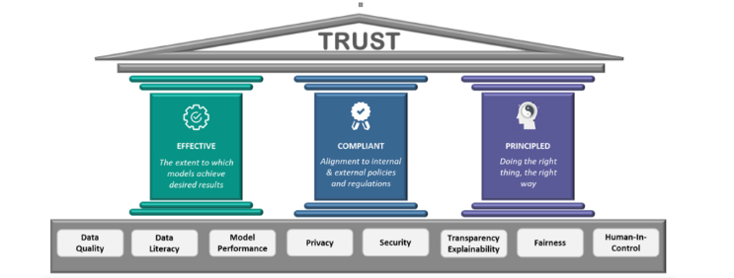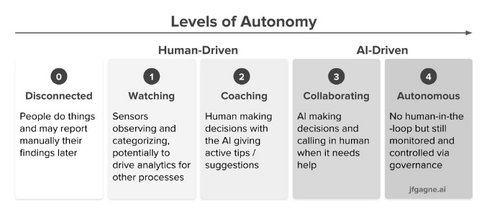

## Q. Good AI exists. Looking at the top companies in the world, we know that a robust framework exists where AI can scale. How do the best compnies in the world build Scalable AI?

A. [How leading companies scale AI. Five key principles to build an AI… | by Wouter Huygen | Towards Data Science](https://towardsdatascience.com/how-leading-companies-scale-ai-4626189faed2)   
[2021_019_001_735330.pdf (cmu.edu)](https://resources.sei.cmu.edu/asset_files/WhitePaper/2021_019_001_735330.pdf)

## Q. What are the difficultes when it comes to scaling implementations of AI?

A. [Scaling AI: 5 Reasons Why It's Difficult | Towards Data Science](https://towardsdatascience.com/scaling-ai-5-reasons-why-its-difficult-6ea77b9f7d48)   
[Scaling AI: How to Make It Work for Your Company | Accenture](https://www.accenture.com/us-en/blogs/intelligent-functions/scaling-ai-how-to-make-it-work-for-your-company)

## Q. State out the Enterprise AI Journey.

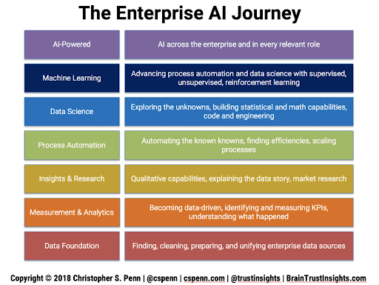

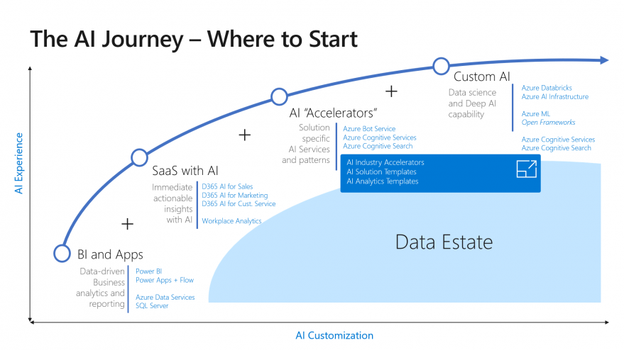

# 6 XAI / Explainable AI

## Q. What are some of the common problems faced by companies when it comes to interpreting AI / ML?

A.

## Q. Explain the concept of XAI and how it can be used in real world implementations?

A. [What is Explainable AI (XAI)?. An introduction to building trust in… | by Nicklas Ankarstad | Towards Data Science](https://towardsdatascience.com/what-is-explainable-ai-xai-afc56938d513)

## Q. If we were to consider AI/ML Models as black boxes that give us the desired output, what are some of the ways to help being trust back to the models being leveraged?

A. [Explainable AI — All you need to know. The what, how, why of explainable AI | by Lawtomated | Medium](https://lawtomated.medium.com/explainable-ai-all-you-need-to-know-the-what-how-why-of-explainable-ai-dcf2287a9f6c)

## Q. Explain some examples of tools and technologies that can help implement interpretable machine learning or XAI.

A. [Explainable AI (XAI) — A guide to 7 Packages in Python to Explain Your Models | by Prateek Bhatnagar | Towards Data Science](https://towardsdatascience.com/explainable-ai-xai-a-guide-to-7-packages-in-python-to-explain-your-models-932967f0634b)

## Q. All of the conversations about XAI seem to be problems of the future. If you were to design a ai / ml model for a business now and productionalize a model, what are some of the considerations you would have as a lead of the project?

A. [Explainable Artificial Intelligence (XAI): Will it be “The Next Big Thing” in AI ? | Medium | Medium](https://medium.com/@arunvaish9/explainable-artificial-intelligence-xai-will-it-be-the-next-big-thing-in-ai-eb240062a822)

# 7 Ethical AI / Federated Learning

## Q. With a world being driven more towards a privacy-focus mentality, what are some of the recommended approaches companies / teams can take to ?

A.

## Q. A common statement is “With the onset of the Digital Era”. In the coming years, as AI startes to take over more and more components of human life, the statement is going to transition to “With the onset of the AI era”. Is Ethical AI a real concern or just hype? What are the ramifications?

A.

## Q. How can Ethical AI be implemented at an enterprise level? What are its implications for Enterprise AI use-cases and Governance?

A.[Ethical AI: its implications for Enterprise AI Use-cases and Governance | by Debmalya Biswas | Towards Data Science](https://towardsdatascience.com/ethical-ai-its-implications-for-enterprise-ai-use-cases-and-governance-81602078f5db)

## Q. With privacy focus coming to the forefront, a lot of attention has been brought on data collected. A new branch of data collection and processing for ai / ml is federated learning. Explain further.

A. [Federated Learning | Towards Data Science](https://towardsdatascience.com/understanding-federated-learning-99bc86a0d026)

## Q. Explain how a model can be monitores after it is moved to production. Break down the approach.

A. [MLOps: Model Monitoring 101 | Towards Data Science](https://towardsdatascience.com/mlops-model-monitoring-101-46de6a578e03)

# 8 Cyber Security AI

A

# 9 RPA: Robotic Process Automation

A

# 10 GANs: Generative Adversarial Networks

A

# **Part-B: Scenario-Based Questions**

## Q. How can NLP be leveraged to tackle Fake News and Cyber Bullying?

## Q. How would you build a governance model for AI in Healthcare. Give examples.

A. [AI Governance on Scalable AI - Google Search](https://www.google.com/imgres?imgurl=https%3A%2F%2Fwww.researchgate.net%2Fprofile%2FSandeep-Reddy-5%2Fpublication%2F337012288%2Ffigure%2Ffig1%2FAS%3A821590203850759%401572893777628%2FOutline-of-the-Governance-Model-for-Artificial-Intelligence-AI-in-Health-Care.png&imgrefurl=https%3A%2F%2Fwww.researchgate.net%2Ffigure%2FOutline-of-the-Governance-Model-for-Artificial-Intelligence-AI-in-Health-Care_fig1_337012288&tbnid=frLGozmuIC-gkM&vet=10CAMQxiAoAGoXChMI4Miyq9mQ8gIVAAAAAB0AAAAAEAs..i&docid=VCDsSUs5zTg_aM&w=850&h=350&itg=1&q=AI%20Governance%20on%20Scalable%20AI&ved=0CAMQxiAoAGoXChMI4Miyq9mQ8gIVAAAAAB0AAAAAEAs)

## Q. Gartner’s report says that 87% of ML Models do not make it to production. What are some of the gaps in the real world when it comes to productionalizing ML Models?

# 1 Real World AI

A

# 2 Mainstream Computer Vision

A

# 3 Federated Learning

A

# 4 Enterprise-Grade AI Solutions

A

# 5 Future of AI

A